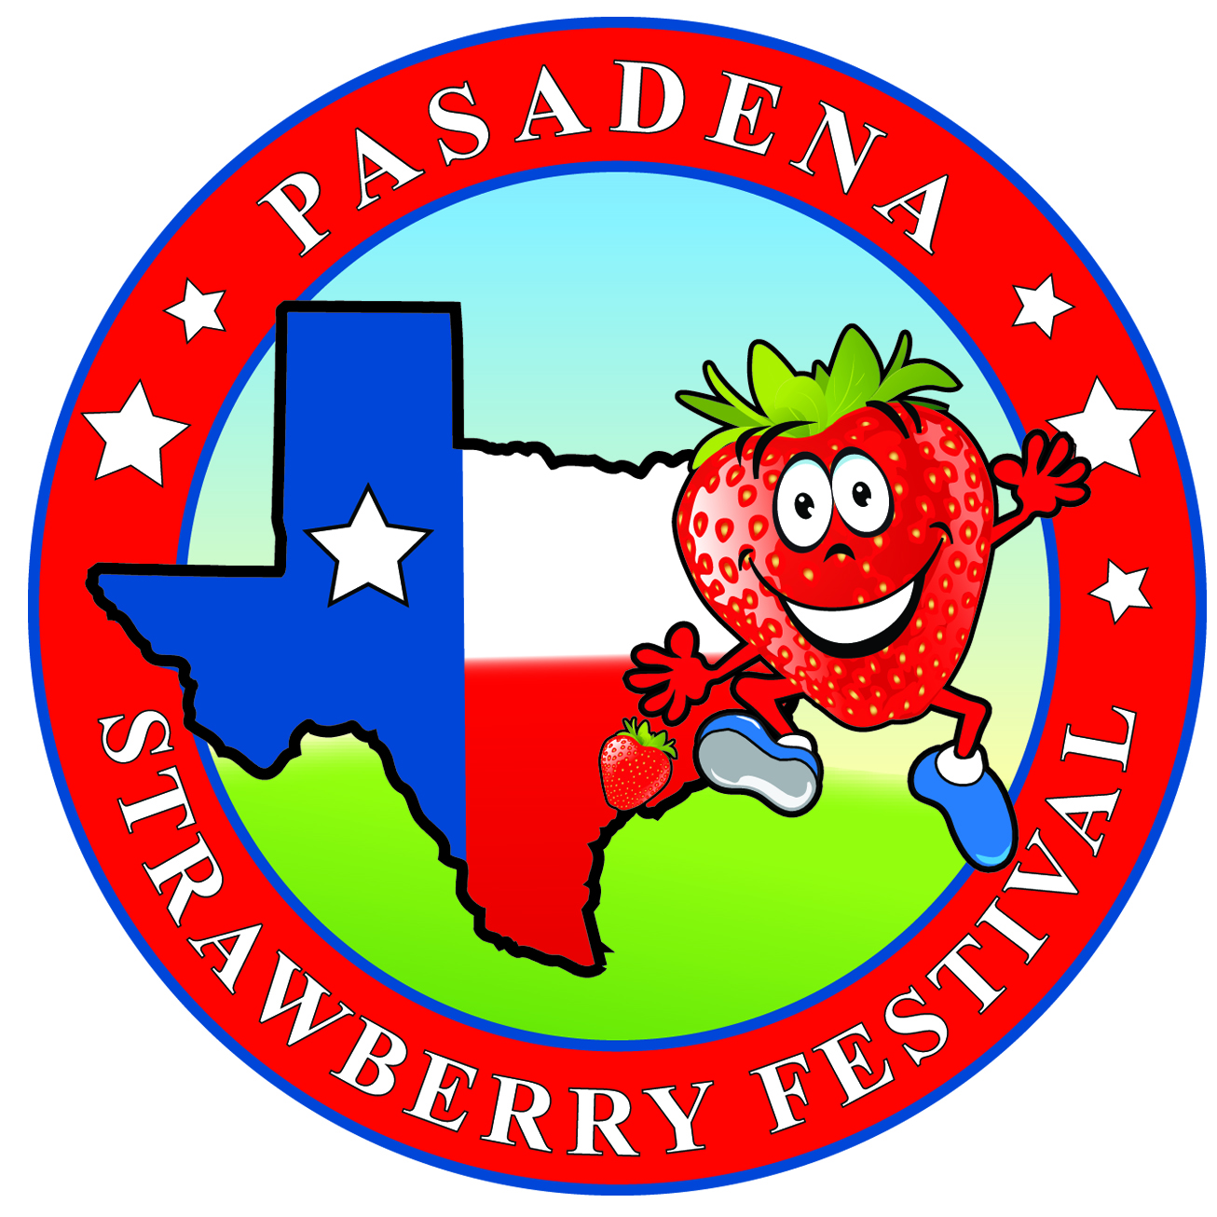
2021 Pasadena
Office Use Only:
Date: __________ Paid by: ___________
Assigned Space# ___________
Strawberry Festival Auto
Show

Name: __________________________________________________________________________
Address: __________________________________ City: _____________________ State:_______
Phone: (Work#) ___________________________ (Cell#) _______________________________
E-Mail address:___________________________________________________________________
Please circle one
Cars & Trucks: Saturday Motorcycles: Sunday
Type of Entry: ( ) Classic ( ) Low Rider ( ) Motorcycle ( ) Ford ( ) G.M. ( ) Dodge ( ) Jeep ( ) Other
Year: __________ Model: ________________
Brief Description of entry: ______________________________________________________________________________________________________________________________________________________________________
___________________________________________________________________________________
Early Registration: ____ $25 (Includes ticket for Driver and one guest)
Event Day Registration: ____ $30 (CASH ONLY)
Total due: $_________
All entries must be inside the gate by 11AM. Awards will be at 3:00PM

PAYMENT METHODS ACCEPTED
__ CASH __BUSINESS OR CASHIER CHECK __ MONEY ORDER __ VISA __ MASTER CARD __ DISCOVER
Credit Card Account # ________________________________________Exp. Date________ CVV#________
Cardholders Name:______________________________ & Signature _______________________________
Cardholders Address:______________________________City___________State____Zip Code__________
Make fees payable to & mail contract to: Pasadena Strawberry Festival 7603 Red Bluff Rd. Pasadena, TX 77507 Fax#: 281-991-8880

WAIVER AND RELEASE OF LIABILITY AND
AGREEMENT TO INDEMNIFY AND HOLD HARMLESS

In consideration of entry into and participation in the activities associated with the PASADENA STRAWBERRY FESTIVAL and in recognition of the risk of injury while participating in FESTIVAL activities and as consideration for the right to participate in the activities, I hereby for myself, my heirs, executors, administrators, assigns, or personal representatives knowingly and voluntarily enter into this WAIVER and RELEASE OF LIABILITY and hereby WAIVE any and all rights, claims, or causes of action of any kind whatsoever arising out of my participation and do hereby RELEASE and forever discharge THE PASADENA STRAWBERRY FESTIVAL and their affiliates, managers, members, agents, attorneys, employees, volunteers, heirs, representatives, predecessors, successors and assigns, the event site and its agents, attorneys, employees, volunteers, heirs, representatives, predecessors, successors and assigns and all sponsors and/or beneficiaries of the FESTIVAL from any and all liability, claims, demands, damages, actions or causes of action of every kind and character now existing or which hereinafter may arise as a result of my participation regardless of cause or whether any injury is caused by the sole, joint, comparative, or concurrent negligence or gross negligence or fault of the FESTIVAL, the negligence or fault of myself or third parties, the conditions of the event site or any other cause.

Further and for the consideration herein described, I agree to INDEMNIFY and HOLD HARMLESS the FESTIVAL against any and all claims, demands, damages, suits or actions of any kind whatsoever for liability, damages, compensation or otherwise brought y me or anyone on my behalf, including attorneys fees, if litigation arises on account of claims made by me or anyone on my behalf caused by negligence, gross negligence, negligence per se, strict liability and/or liability under the Deceptive Trade Practices Act or other fault regardless of cause or whether caused by the sole, joint, comparative, or concurrent negligence, gross negligence or fault of the FESTIVAL, my own fault or the fault of third parties, the conditions of the event site or any other cause. To INDEMNIFY means to assume the liability in a situation, thereby relieving the other party of responsibility.

I recognize that various photographs, video recordings and/or other media will be taken during the FESTIVAL’s activities. I agree to grant the FESTIVAL full permission to use any photographs, video recordings, or other media of the FESTIVAL activities that contain my likeness for the purpose of promoting the FESTIVAL or its SPONSORS in any manner deemed appropriate by the FESTIVAL. I further agree to RELEASE and INDEMNIFY the FESTIVAL for any claims of NEGLIGENCE, GROSS NEGLIGENCE, NEGLIGENCE PER SE, STRICT LIABILITY or LIABILITY under the DECEPTIVE TRADE PRACTICES ACT or other fault for claims made that relate to any usage of photographs and/or interviews, including but not limited to damages, losses, costs of defense, attorney’s fees and whether caused by the sole, joint, comparative or concurrent negligence, gross negligence or fault of the FESTIVAL or myself or third parties, the conditions of the event site or any other cause.

I hereby declare that I have read and fully understand this Agreement in its entirety and that, by signing (or clicking) below, I assent to the terms and conditions contain this Agreement.

__________________________________________ _________________________
Signature Date

